Lab Report: 2

*Course title: Computer Graphics Lab*

*Course code: CSE-304*

*3rd Year 1st Semester Laboratory*

***Date:*** *04/06/2023*



**Submitted to-**

***Prof. Mohammad Shorif Uddin***

***Professor***

***Dr. Morium Akter***

***Assistant Professor***

*Department of Computer Science and Engineering*

*Jahangirnagar University*

*Savar, Dhaka*

| **Name** | **Class Roll** | **Exam Roll** |
| --- | --- | --- |
| Abdus Salam | 2148 | 191366 |

**Work -1:Midpoint Algorithm**

**Source Code**

#include<bits/stdc++.h>

#include<conio.h>

#include<graphics.h>

#include<math.h>

using namespace std;

//void display();

float x,y;

int xc,yc;

void display()

{

putpixel(xc+x,yc+y,8);

putpixel(xc-x,yc+y,8);

putpixel(xc+x,yc-y,8);

putpixel(xc+x,yc-y,8);

}

int main()

{

int gd=DETECT,gm,a,b;

float p1,p2;

initgraph(&gd,&gm,"c:\\turboc3\\bgi");

printf(" Ellipse Generating Algorithm \n\n");

printf("Enter the value of Xc\t");

scanf("%d",&xc);

printf("Enter the value of Yc\t");

scanf("%d",&yc);

printf("Enter X axis length\t");

scanf("%d",&a);

printf("Enter Y axis length\t");

scanf("%d",&b);

x=0;

y=b;

display();

p1=(b*b)-(a*a*b)+(a*a)/4;

while((2.0*b*b*x)<=(2.0*a*a*y))

{

x++;

if(p1<=0)

p1=p1+(2.0*b*b*x)+(b*b);

else

{

y--;

p1=p1+(2.0*b*b*x)+(b*b)-(2.0*a*a*y);

}

display();

x=-x;

display();

x=-x;

delay(50);

}

x=a;

y=0;

display();

p2=(a*a)+2.0*(b*b*a)+(b*b)/4;

while((2.0*b*b*x)>(2.0*a*a*y))

{

y++;

if(p2>0)

p2=p2+(a*a)-(2.0*a*a*y);

else

{

x--;

p2=p2+(2.0*b*b*x)-(2.0*a*a*y)+(a*a);

}

display();

y=-y;

display();

y=-y;

delay(50);

}

getch();

closegraph();

}

**Output Screenshot:**

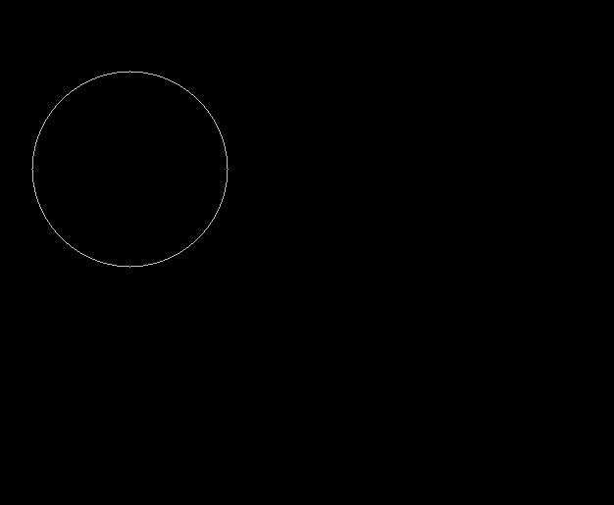

**Work-2:Scan Convert an Ellipse**

**Source code:**

#include<bits/stdc++.h>

#include<conio.h>

#include<graphics.h>

#include<math.h>

using namespace std;

//void display();

float x,y;

int xc,yc;

void display()

{

putpixel(xc+x,yc+y,8);

putpixel(xc-x,yc+y,8);

putpixel(xc+x,yc-y,8);

putpixel(xc+x,yc-y,8);

}

int main()

{ int gd=DETECT,gm,a,b;

float p1,p2;

initgraph(&gd,&gm,"c:\\turboc3\\bgi");

printf(" Ellipse Generating Algorithm \n\n");

printf("Enter the value of Xc\t");

scanf("%d",&xc);

printf("Enter the value of Yc\t");

scanf("%d",&yc);

printf("Enter X axis length\t");

scanf("%d",&a);

printf("Enter Y axis length\t");

scanf("%d",&b);

x=0;

y=b;

display();

p1=(b*b)-(a*a*b)+(a*a)/4;

while((2.0*b*b*x)<=(2.0*a*a*y))

{

x++;

if(p1<=0)

p1=p1+(2.0*b*b*x)+(b*b);

else

{

y--;

p1=p1+(2.0*b*b*x)+(b*b)-(2.0*a*a*y);

}

display();

x=-x;

display();

x=-x;

delay(50);

}

x=a;

y=0;

display();

p2=(a*a)+2.0*(b*b*a)+(b*b)/4;

while((2.0*b*b*x)>(2.0*a*a*y))

{

y++;

if(p2>0)

p2=p2+(a*a)-(2.0*a*a*y);

else

{

x--;

p2=p2+(2.0*b*b*x)-(2.0*a*a*y)+(a*a);

}

display();

y=-y;

display();

y=-y;

delay(50);

}

getch();

closegraph();

}

**Output ScreenShoot:**

